EMERGING FROM LOCKDOWN
FACING THE SHADOW, EMBRACE THE JOY ...
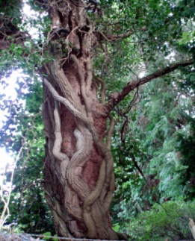
A TRANSFORMATIVE JOURNEY INTO CO CREATING WITH YOUR UNCONSCIOUS

Fancy JOINING A WEEKLY ZOOM ONLINE DREAM GROUP?
~ DISCOVERING + PRACTISING SELF HELP DREAMWORK METHODS ~
As we slowly prepare to emerge from lockdown, why not really” go inside”
to explore the mystery, fears, creativity and meaning of your own dream symbols?
As we imagine into the coming year, why not bring your dreams to life by exploring each
week some helpful shamanic methods......using the dream ego, dialogue, artwork,
key questions, working with nightmares, “dream tasks”+ inner work between sessions

: 7 weekly sessions run from Forres, with Gelda MacGregor
Group three : evening 7- 9pm from Feb 24th - 7th April : max 5 folk

Gelda is an experienced therapist and counsellor who trained intensively in Edinburgh
for 3 years in Jungian Senoi Dreamwork, led by Hilary Scaife and Strephon Kaplan
Williams, author of the “Dreamwork Manual” and “Transforming Childhood.”
She initially learned about dreams in groups led by Dr.Winifred Rushforth, who was trained
as Carl Gustav Jung`s first psychotherapist in Scotland,and worked with dreams till she was 93!
Gelda has run Jungian Senoi dream groups for many years, in Edinburgh then Forres,Moray.
For the first time she is taking them online, as a creative lockdown opportunity...this work
may help with anxiety and fears of loss and disempowerment, due to current outer restrictions.

Meeting online, with commitment + confidentiality, cost £15 per session or £10 concession
Contact Gelda on 01309 694826 or swallow.flight@zen.co.uk or discuss free via Zoom

Recent testimonial from client B.B. Dec 2020: “it has been wonderful and challenging
to go to that place of insight, revelation and understanding”

